Aerobatics Black Box

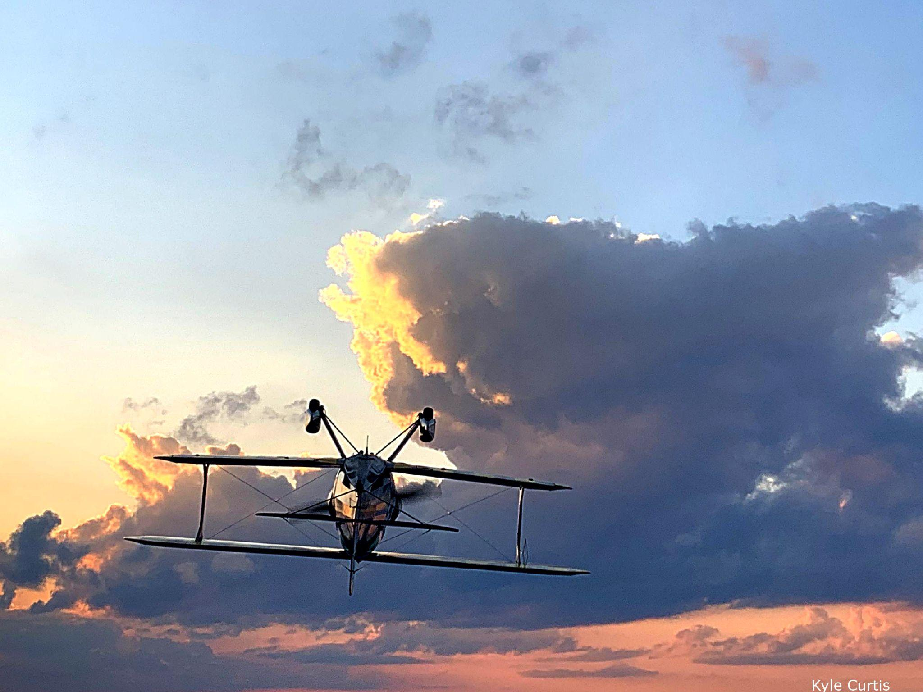

# Client need

Aerobatics pilots would like to correlate their control inputs to the airplane’s behavior, and to be able to visualize what the maneuver looked like from the ground.

# Project description

Students will develop the instrumentation package and then (if desired) accompany the pilot during flight testing.

Required data

* Attitude (roll-pitch-yaw)
* Position (latitude-longitude-altitude)
* Control input (Flight stick, rudder pedal, throttle, and mixture)
* Flight gauges (tachometer, altimeter, airspeed indicator...)

Collecting this data requires instrumenting the airplane for a full AHRS (Attitude Heading Reference System) and INS (Inertial Navigation System). In addition, image analysis techniques are necessary for monitoring the cockpit flight gauges. Lastly, both electromechanical and optical sensors are valid options for measuring the pilot’s control inputs.

# Deliverables

The students will deliver a system capable of being installed into an aerobatic airplane; measuring the pilot’s inputs and the airplane’s outputs; and visualizing the aerobatic maneuver from an arbitrary camera angle (e.g. using Google Earth).

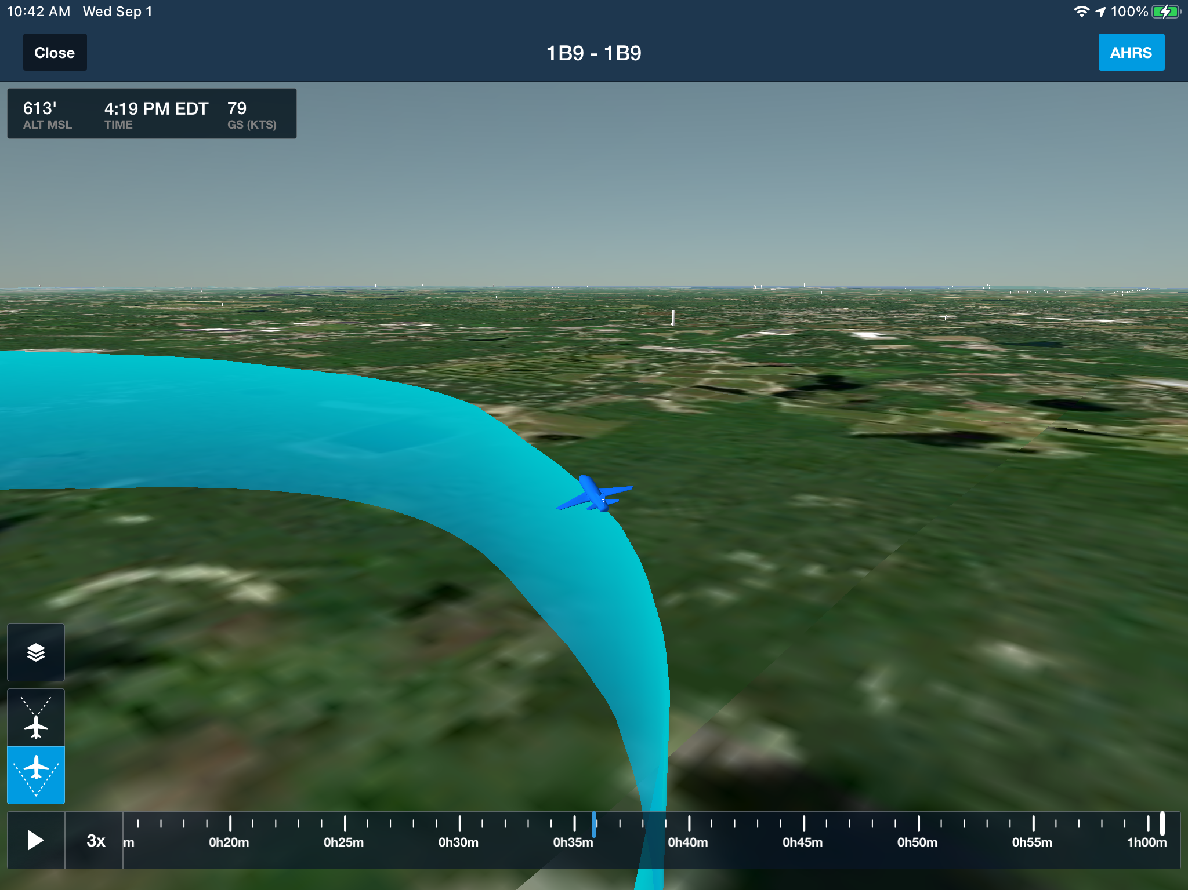

# Contact information

CyPi Ltd.

Dr. Kenneth D. Sebesta

[kenn@cypiltd.com](mailto:kenn@cypiltd.com)

859-648-0272

# Items to be supplied by client

* Two-seater aerobatics airplane
* Aerobatics pilot

# Intellectual property

Any patents or papers to be shared equally with team members.